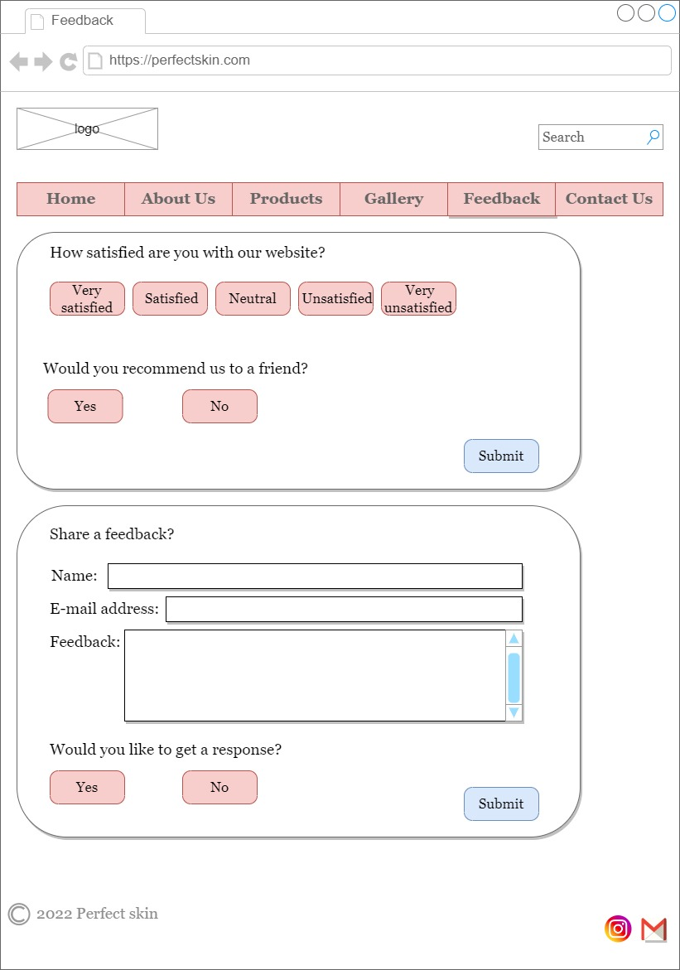Eman

Website URL

Linking to our social media accounts

The user can choose whether she/he want to get a response from our team or only want to share an opinion

The user can submit one or both forms to share her/his thoughts about the website

Submit button

Content bar, the chosen option will be shaded

Website logo

Option to search in the website

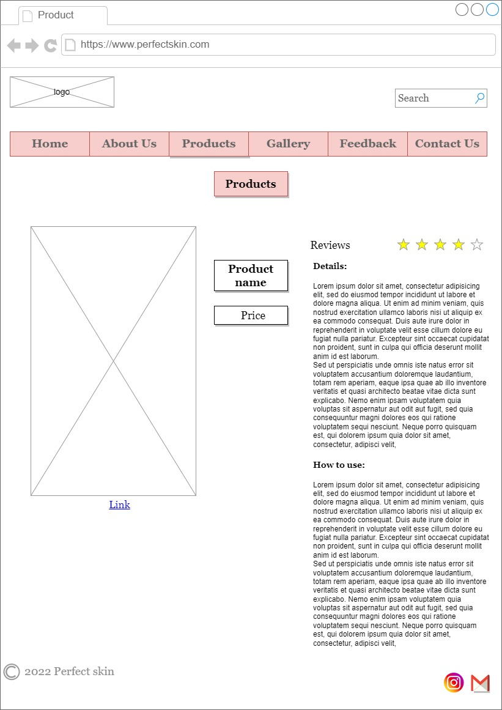

Website URL

Website logo

Option to search in the website

Content bar, the chosen option will be shaded

Option to rate the product out of five

Paragraphs that explain and describe the product, its contents, and how to use it

Display name and price of the product

Hyperlink to another website that sells the product

Photo of the product

Linking to our social media accounts